**Supplementary Information for**

**A Multifunctional Robotic System toward Moveable Sensing and Energy Harvesting**

Yiqiang Fua,b,c, Hongqiang Wanga,b,d,*, Yunlong Zic,**, Xuanquan Lianga,b

a Shenzhen Key Laboratory of Biomimetic Robotics and Intelligent Systems, Department of Mechanical and Energy Engineering, Southern University of Science and Technology, Shenzhen, Guangdong, 518055, China.

b Guangdong Provincial Key Laboratory of Human-Augmentation and Rehabilitation Robotics in Universities, Southern University of Science and Technology, Shenzhen, Guangdong, 518055, China.

c Department of Mechanical and Automation Engineering, The Chinese University of Hong Kong, Shatin, N.T., Hong Kong SAR, China.

d Southern Marine Science and Engineering Guangdong Laboratory, Guangzhou, Guangdong, China.

* Corresponding author: Hongqiang Wang ([wanghq6@sustech.edu.cn](mailto:wanghq6@sustech.edu.cn)).

** Corresponding author: Yunlong Zi ([ylzi@cuhk.edu.hk](mailto:ylzi@cuhk.edu.hk)).

**This file includes:**

Fig. S1. Experimental setups for the measurements of the normal and tangential adhesion forces between the electroadhesive foot and a conductive substrate under different DC voltages.

Fig. S2. Loading curves under both normal and tangential tensions at 300 V as examples.

Fig. S3. Experimental setup for the measurement of the robot’s extensions under different amplitude-modulated voltage actuations.

Fig. S4. Experimental setup for testing the climbing ability of the robot.

Fig. S5. Experimental setup for the measurement of the electrical outputs of the robot under different base excitations.

Fig. S6. Time histories of the open-circuit voltage outputs of the robot at the start and the end of decaying.

Fig. S7. Schematic diagram of the circuit used for charging a capacitor.

Fig. S8. Time histories of the supplied voltage (bule dashed line) to the foot and the current (red solid line) in circuit.

Table S1. Values of the parameters used for the simulation of normal and tangential adhesion forces.

Table S2. The inrush current and power and the leakage current and power in multiple tests.

**Other supplementary information for this paper includes the following:**

Movie S1. Vibration of the actuation body under AM voltages of different carrier amplitudes.

Movie S2. Vibration of the actuation body under sinusoidal voltages of different amplitudes.

Movie S3. Locomotion of the robot with only the actuation body working.

Movie S4. Climbing a ramp of around 5 degrees of incline.

Movie S5. Demonstration of the robot for locomotion, energy harvesting, vibration sensing and video monitoring.

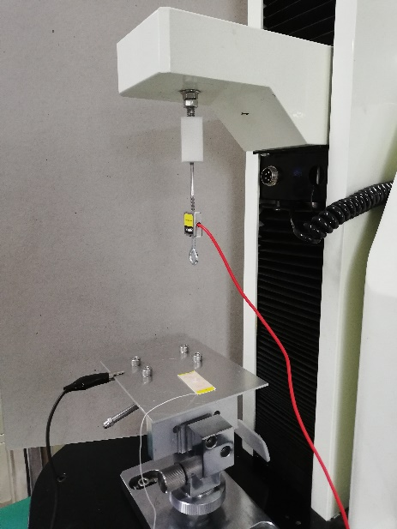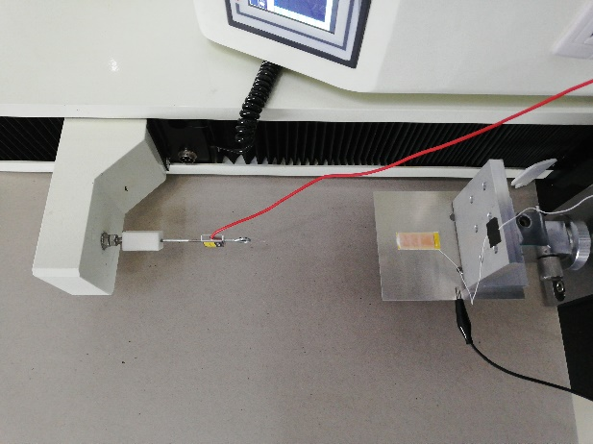

a

b

Tension machine

Load cell

Substrate

Foot

Fig. S1. Experimental setups for the measurements of the (a) normal and (b) tangential adhesion forces between the electroadhesive foot and a conductive substrate (Al) under different DC voltages (the string used to connect the foot and the load cell is transparent and relatively thin and thus is difficult to be identified in photos above).

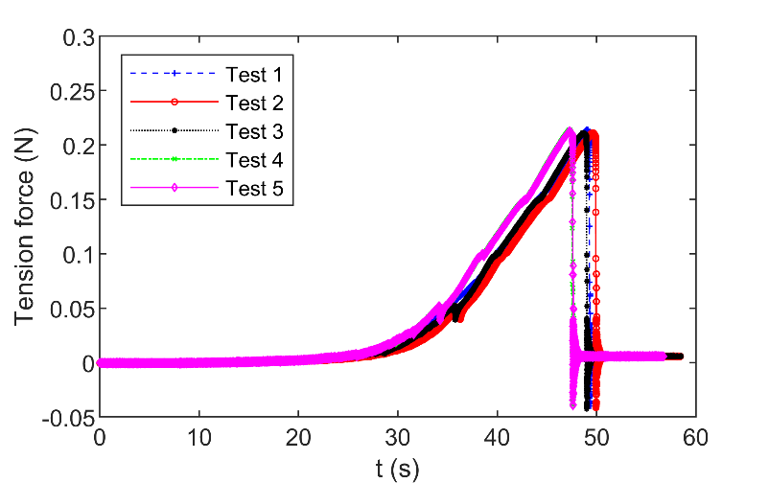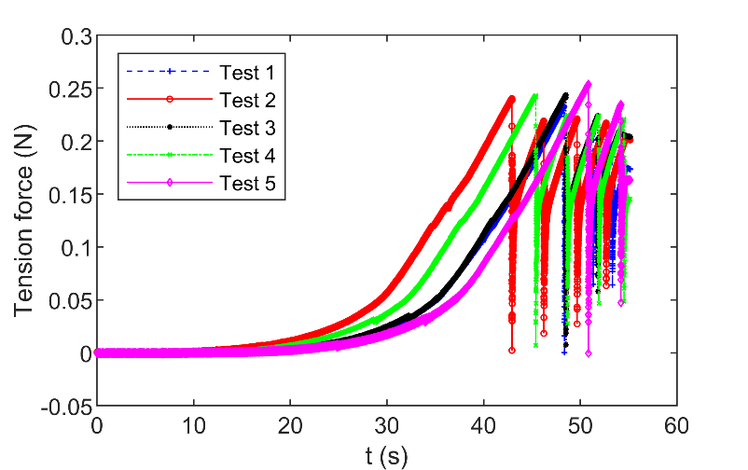

a

b

Fig. S2. Loading curves under both (a) normal and (b) tangential tensions at 300 V as examples.

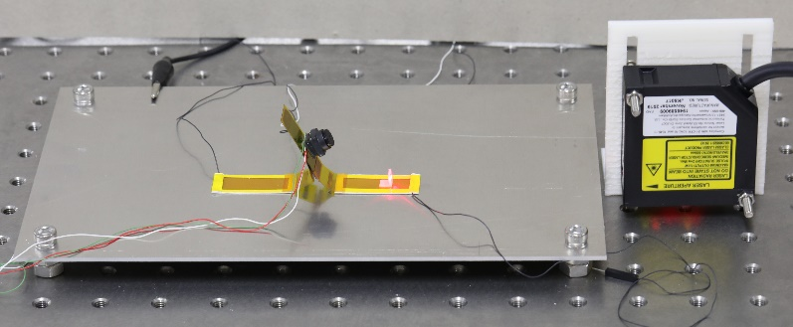

Robot

Reflection plate

Laser displacement sensor

Substrate (Al)

Rear foot fixed

Front foot free

Fig. S3. Experimental setup for the measurement of the robot’s extensions under different amplitude-modulated voltage actuations.

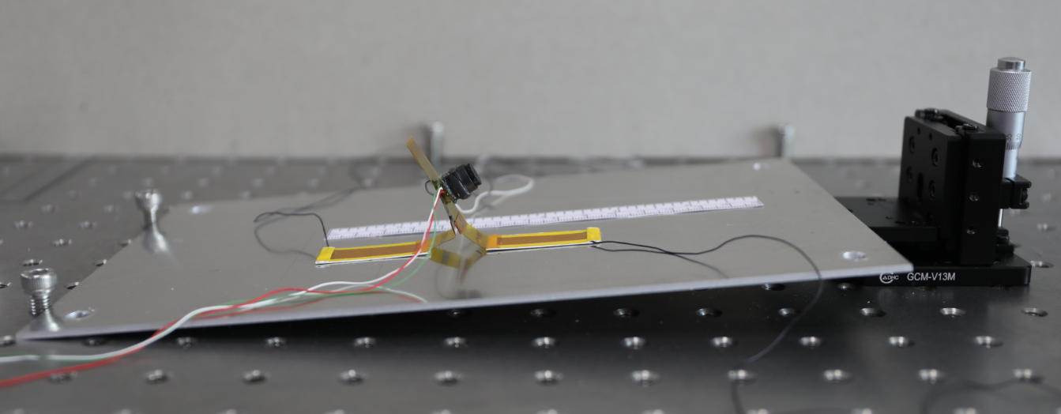

Lifter

Ramp

Robot

Fig. S4. Experimental setup for testing the climbing ability of the robot.

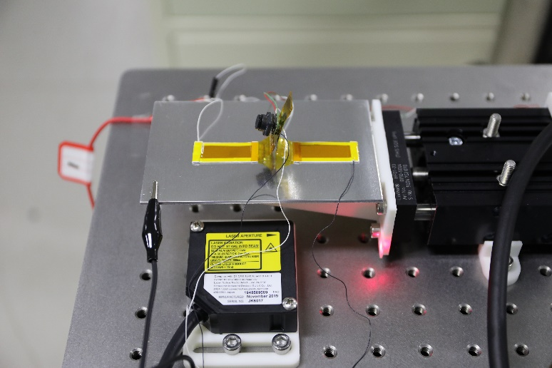

Robot

Laser displacement sensor

Vibration platform

Laser measurement point

Shaker

Both feet fixed

Fig. S5. Experimental setup for the measurement of the electrical outputs of the robot under different base excitations.

a

b

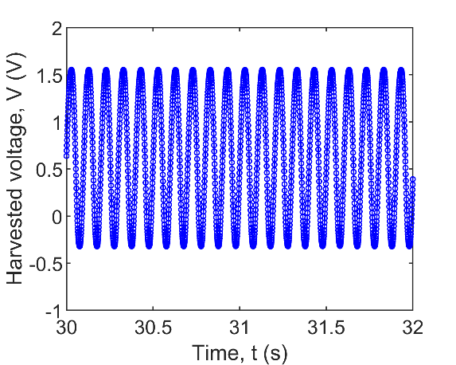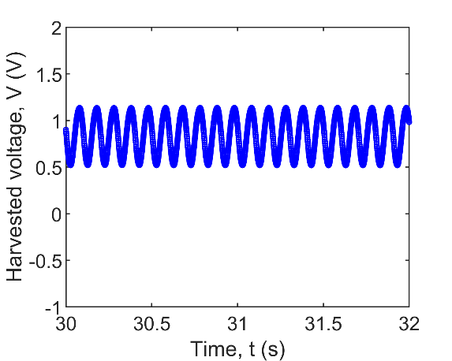

Fig. S6. Time histories of the open-circuit voltage outputs of the robot at (a) the start and (b) the end of decaying.

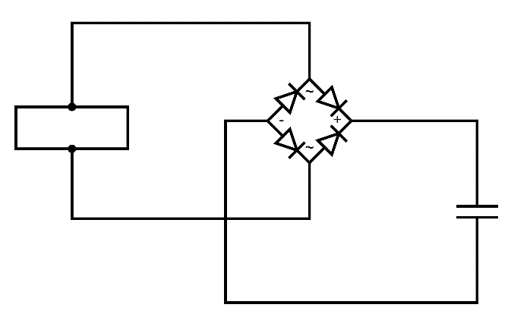

Robot

Fig. S7. Schematic diagram of the circuit used for charging a capacitor.

Table S1. Values of the parameters used for the simulation of normal and tangential adhesion force.

|  |  |
| --- | --- |
| **Parameter** | **Value** |
| Dielectric constant of the air, $ε_{air}$ | 1 |
| Dielectric constant of the insulator, $ε_{ins}$ | 40 |
| Area of the foot, $S$ | $15×35$ ${mm}^{2}$ |
| Thickness of the insulator, $t_{ins}$ | 30 $μm$ |
| Thickness of the thin air gap, $t_{air}$ | 31.66 $μm$ |
| Coefficient of friction, $μ_{e}$ | 1.4673 |

To obtain the power consumption of the electrostatic adhesion foot, an electrometer (Keithley Model 6514) is connected to the foot in series to measure the current in circuit. The supplied DC voltage to the foot is 300 V.

An example of the time histories of the supplied voltage and the current is shown in Figure S8. Initially, the current is zero. When the DC voltage is turned on, there appears an inrush current or a switch-on current that peaks at 177.19 $μA$, and then the current immediately drops to a normal level and gradually reaches a steady state. The steady-state current or the so-called leakage current is around 0.19 $μA$.



Fig. S8. Time histories of the supplied voltage (bule dashed line) to the foot and the current (red solid line) in circuit.

Since the leakage current can be affected by temperature, humidity, time, etc., multiple measurements are conducted to obtain the mean value and the standard deviation. The results are concluded in Table S2. The mean inrush current and power of eight tests are 157.67 μA and 47.23 mW. Both of the standard deviations of the inrush current and power are relatively large, which is because the measurement of the inrush current is not easy and usually requires devices of high sampling rate. Nevertheless, the inrush power cannot be an accurate reference for the actual power consumption of the foot. The mean leakage current and power are 0.16 μA and 47.78 μW, and the standard deviations are relatively small. Therefore, the power consumption of the foot is 47.78 μW, and that of the robot would be doubled (two feet) and is around 0.1 mW.

Table S2. The inrush current and power and the leakage current and power in multiple tests.

|  |  |  |  |  |
| --- | --- | --- | --- | --- |
| Parameters  No. | Inrush current ($μA$) | Inrush power ($mW$) | Leakage current ($μA$) | Leakage power ($μW$) |
| 1 | 213.21 | 63.98 | 0.19 | 55.88 |
| 2 | 103.95 | 31.08 | 0.18 | 54.24 |
| 3 | 177.19 | 53.06 | 0.19 | 56.97 |
| 4 | 131.50 | 39.40 | 0.15 | 43.98 |
| 5 | 150.62 | 45.08 | 0.14 | 41.27 |
| 6 | 205.12 | 61.49 | 0.15 | 44.04 |
| 7 | 177.55 | 53.15 | 0.15 | 45.65 |
| 8 | 102.22 | 30.59 | 0.13 | 40.24 |
| Mean | 157.67 | 47.23 | 0.16 | 47.78 |
| Standard deviation | 42.77 | 12.85 | 0.02 | 6.81 |